Software Requirements Specification (SRS) – ABS ECU Simulation

1. Introduction

1.1 Purpose
This document defines the software requirements for the simulation of an Anti-lock Braking System (ABS) Electronic Control Unit (ECU) in Simulink.
The objective is to demonstrate the basic ABS operation, including wheel lock detection and brake pressure modulation via Pulse Width Modulation (PWM).

1.2 Scope
- The simulation represents a simplified version of an ABS ECU.
- Intended for educational and logic validation purposes.
- No integration with real hardware.

1.3 References
- Automotive software development standards:
  - ISO 26262 (Functional Safety)
  - ASPICE (Automotive SPICE)
- ABS ECU operational logic reference documentation.

1.4 Definitions and Acronyms
Term / Acronym | Definition
ABS | Anti-lock Braking System
ECU | Electronic Control Unit
PWM | Pulse Width Modulation
Slip | Relative difference between wheel speed and reference vehicle speed
Scope | Simulink visualization block
FL, FR, RL, RR | Front Left, Front Right, Rear Left, Rear Right wheels

2. System Overview
The simulated ABS ECU:
- Monitors four wheel speeds.
- Calculates slip for each wheel.
- Detects wheel lock conditions.
- Activates ABS control logic.
- Modulates brake valve pressure via PWM signal.
- Displays signals on Simulink scopes for analysis.

3. Functional Requirements
ID | Requirement Description | Acceptance Criteria
RF-01 | The system shall receive as inputs: (a) speed of four wheels (Step blocks), (b) reference vehicle speed (Constant block). | Inputs correctly connected and providing expected signal values in simulation.
RF-02 | The system shall calculate wheel slip according to the equation:  Slip = (V_wheel-V_vehicle) / V_vehicle | Slip value calculated for each wheel within ±0.001 accuracy.
RF-03 | The system shall detect wheel lock when slip < -0.2 and set logical lock signal to 1 (true). | Lock signal activates within 10 ms of threshold breach.
RF-04 | The ABS shall activate (ativar_abs = 1) when any wheel lock signal = 1.  Input signals:  - estado_roda_de (FL)  - estado_roda_dd (FR)  - estado_roda_te (RL)  - estado_roda_td (RR)  Output signal: ativar_abs | ABS activation occurs within 10 ms of lock detection.
RF-05 | The PWM control shall operate as follows:  - ABS deactivated: duty cycle = 90% (high pressure)  - ABS activated: duty cycle = 30% (pressure reduction)  - Frequency: 200 Hz  - Amplitude: 5V | Duty cycle change occurs within 5 ms of ABS activation/deactivation.
RF-06 | The system shall display in Simulink Scopes:  - Scope Input: wheel speeds and reference speed  - Scope Output: ABS activation signal and PWM | Scope signals visible, updated in real-time during simulation.

4. Non-Functional Requirements
ID | Requirement Description | Acceptance Criteria
RNF-01 | Model shall be compatible with Simulink R2024 or later. | Opens and runs without error in Simulink R2024+.
RNF-02 | Sampling frequency adequate for up to 200 Hz signals. | No aliasing observed in PWM waveform.
RNF-03 | System shall be modular, allowing modification of slip threshold and duty cycle. | Changes can be applied without altering unrelated modules.

5. Expected Results
- Lock detection occurs ~1s after simulated braking.
- ABS activation signal (ativar_abs) remains at 1 during critical slip period.
- PWM duty cycle switches between 90% and 30% according to ABS activation state.

6. Logic Model

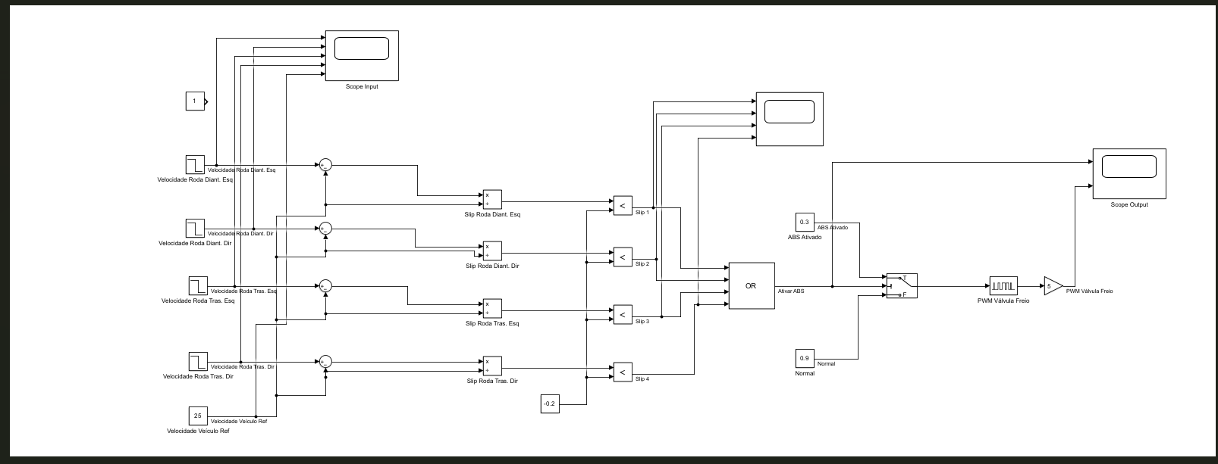
- Wheel speed reading
- Slip calculation
- Lock detection
- ABS activation logic
- PWM control update)

